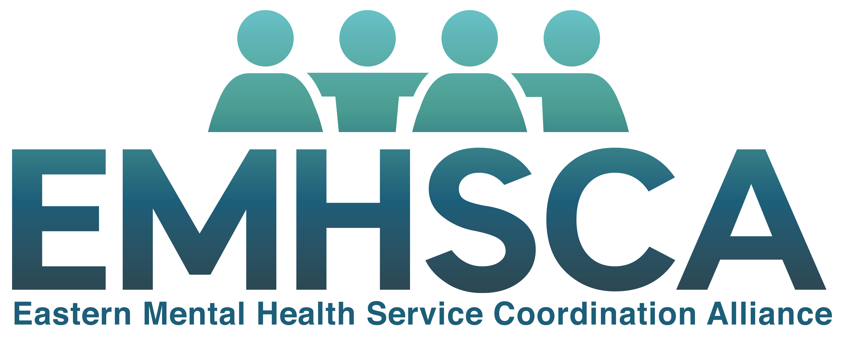

Co-location Guide

“Creating opportunities to work strategically across the region with Multi- Sectoral partners”

Background

EMHSCA
The Eastern Mental Health Service Coordination Alliance (EMHSCA) was formed in 2009, and currently involves 31 health and community support organisations signed into an MOU. The EMHSCA aim is to strengthen Mental Health and AOD service collaboration, coordination and system integration across Inner- and Outer- Eastern Melbourne for improved consumer outcomes. EMHSCA functions as the key local platform for health and community service consultation and collaborative decision making in the region. This Alliance has signed up to the implementation of the EMHSCA Shared care protocol, including associated workforce development.

EMHSCA Membership
Access Health & Community Services
Anglicare
Campbell-Page
Carrington Health & Community Services
Department of Health
Dual Diagnosis Consumer and Carer Advisory Council & Working Group
EACH
Eastern Community Legal Centre
Eastern Health Mental Health Services
Eastern Health Turning Point
Eastern Homelessness Service System Alliance
Eastern Melbourne PHN
EMR Regional Family Violence Partnership
Foundation House
Independent Mental Health Advocacy
Inner East Primary Care Partnership
Inspiro
JobCo.
Latrobe Community Health Service
Knox, Maroondah and Whitehorse City Councils
MIND Australia
Mullum Mullum Indigenous Gathering Place
NEAMI National
NEXTT
Outer East Health and Community Support Alliance
The Salvation Army
Services Australia
Uniting
Wellways
Wise employment
YSAS

Objectives of this Guide
- To support EMHSCA members to provide more integrated services to people with mental ill health and co-occurring issues.
- To promote the idea of co-location as a means to provision of more integrated services in the Eastern Metro Region.
- To assist EMHSCA services to successfully co-locate by providing advice regarding logistics and potential challenges.

Co-location Model

Definition
The term ‘Co-location’ refers to the location of a worker from one service at the site of another service e.g. a mental health worker at a community health service. This arrangement is intended to support a more integrated service response to people with co-occurring concerns. Co-location arrangements should provide benefits to both the host organisation and the co-locator.

Evidence base
Co-location is not new. There are a number of examples of co-location already within EMHSCA. These have been mapped in an effort to understand the various logistics and challenges. In 2016, the EMHSCA Collaborative Pathways subcommittee reviewed relevant literature, and their findings supported the results of the EMHSCA co-location mapping exercise. Relevant references are included in a bibliography with this guide.

Enablers of co-location

Leadership commitment
- Staff willingness for the change
- Regular monitoring and evaluation
- MOU/ partnership agreement clarifying roles and responsibilities
- Learning from others who have co-located

Advantages of co-location
Co-location arrangements often aim to improve referral pathways and may also lead to improved client outcomes (both physical and mental) and reduced stigma associated with seeking mental health care which arises from improved knowledge sharing and collaboration between service providers (Mauro et al 2016; Williams et al 2006). Whiteford et al (2014) provided a qualitative systematic review that identified improvements in communication; mutual understanding and empathy resulted from co-location arrangements.
A summary of the benefits of co-location include:
- Service integration provides a one-stop-shop for service users
- Promotion of both the host and collocated services
- Improves staff knowledge of other sectors/services
- Services are presented to the consumer as connected/collaborative
- Opportunities to share knowledge
- Increased good will between staff
- Mutual support between staff and strengthening of partnership
- Facilitates clearer and easier referral pathways
- Barriers to collaboration between staff are reduced
- Ability to share training opportunities
- Reduces need for referral when waiting lists are long
- Resource sharing
- Improved access to secondary consultation

Challenges of co-location
Mauro et al (2016) examine various public and private service coordinated care practices and warn that co-location isn’t sufficient to support integrated treatment if there are no integrative processes that result in a single treatment plan for consumers. Among their recommendations for a more integrated treatment approach they suggest, ensuring timely follow-up, being specific when identifying clients who require additional follow-up, and providing good support for colleagues (Mauro et al 2016). HealthOne NSW (2012) advise that the time and effort required in properly setting up co-location arrangements should not be underestimated and a committed practice manager along with setting clear deadlines are important for success.
Common challenges include:
- Privacy concerns of both services. Trust is essential for breaking this down.
- Logistical issues (such as car spaces, site access hours etc.)
- Desk space
- IT (internet / printing access etc.)
- Managing off site staff members requires trust and good selection of staff to be co-located
- Managing staff leave and resources
- Handover between staff
- Risk management
- Differing policy and procedure
- Admin access
- Increased preparation time for program delivery
- Increased travel time
- Limited staff resources are further limited at the co-locating service’s home site
- Can’t always offer a service in a timely manner due to waitlists
- Gaps in service provision
- Fluctuations in service needs and meeting times.

How to get the ball rolling
- Services should actively identify who they would like to work more closely with.
- Identify key people from identified service to work with in setting up co-location.
- Consider and discuss benefits to all parties.
- Decide who will host and who will collocate depending on suitability and space availability.
Prior to co-location, consideration needs to be given to the following
- Local policy and emergency procedures
- Suitable accommodation
- Sharing of resources including administration support
- IT and internet access
- Travel distance and parking arrangements
- Access cards or keys

Things to consider in planning and implementation

Set up
- It is important to draw up co-location arrangements to ensure clarity of the proposal.
- Clearly define which services are involved in the partnership. This is particularly important if co-location is at a site that provides multiple services.
- Set up clear communication policies for things such as sick leave etc.
- Set up a clear MOU at the outset that includes dispute resolution provisions.

Orientation
- Organise a ‘meet and greet’ prior to the co-location commencing.
- Orient co-locating staff to host site and provide resources as required such as admin support if possible.
- Make co-located staff a part of the host team (invite them to meetings, lunches etc.).
- Ensure good orientation to site’s facilities and procedures especially emergency procedures.

Logistics
- Co-located staff should be physically available when needed by host service staff. This can be supported by having multiple people co-located at the same site.
- Ensure all staff at the host site are aware of the co-locating staff.
- Physically locate co-located staff in a central location to facilitate interaction with host staff.
- Maintain a flexible approach as service needs fluctuate on a daily basis.

Co-location during COVID-19
- All staff who co-locate at services during COVID-19 should ensure that they read and follow the COVID Safe Plan at the co-location site.
- Staff who work at different sites (including co-locations) will need to follow local processes to ensure COVID Safe practice - this includes checking in to each site using the site-based QR code or other check-in system.
- At times there may be restrictions on staff working across multiple sites in line with Government COVID-19 restrictions. Staff are reminded to follow these restrictions at all times. Remote processes may be required to maintain integrated practices.
- Staff must ensure that they do not attend the site if they are feeling unwell or have any symptoms of illness, and should continue to practice hand hygiene whilst co-locating.

Bibliography

Blue-Howells, J, McGuire, J & Nakashima, J 2008, Co-Location of Health Care Services for Homeless Veterans: A Case Study of Innovation in Program Implementation, Social Work in Health Care, 47:3, 219-231, DOI:10.1080/00981380801985341
Floyd, P 2016, Integrating Physical and Behavioural health in the US- a major step toward health management- Healthcare financial management
HealthOne NSW 2012, Guidelines for developing HealthOne NSW Services, NSW Government
Healthwest 2013, Progressing toward an Active Service Model: Examples of co-location from HACC services,
Mauro, P, Furr-Holden, D, Strain, E, Crum, R, Mojtabai, R 2016, Classifying substance use disorder treatment facilities with co-located mental health services: A latent class analysis approach, g and Alcohol Dependence 163 (2016) 108–115
Reiss-Brennan, B, Briot, P, Savitz, L, Cannon, W, Staheli, R 2010, Cost and Quality Impact of Intermountain's Mental Health Integration Program, Journal of Healthcare Management 55:2 March/April 2010.
Walsh, P, McGregor-Lowndes, M & Newton, C 2006, Shared Services: Lessons from the Public and Private Sectors for the Nonprofit Sector, CPNS Working Paper No 34. Brisbane: QLD.
Whiteford, H, McKeon, G, Harris, M, Diminic, S, Siskind, D & Scheurer, R 2014, System-level intersectoral linkages between the mental health and non-clinical support sectors: a qualitative systematic review, Australian & New Zealand Journal of Psychiatry 2014, Vol. 48(10) 895–906 DOI: 10.1177/0004867414541683
Williams, J, Shore, S, Meschan Foy, J 2006, Co-location of Mental Health Professionals in Primary Care Settings: Three North Carolina Model, Clin Pediatr. 2006;45:537-543, Sage publications DOI: 10.1177/0009922806290608
Wilson, R & Usher, K 2015, Rural nurses: a convenient co-location strategy for the rural mental health care of young people. J Clin Nurs, 24: 2638–2648. doi:10.1111/jocn.12882
Wilson, R & Usher, K 2015, Rural nurses: a convenient co-location strategy for the rural mental health care of young people, Journal of Clinical Nursing, 24, 2638–2648, doi: 10.1111/jocn.12882

Developed by the Eastern Mental Health Service Coordination Alliance (EMHSCA)
Creative Commons
You are free to share and adapt the content as per the creative commons license provided the EMHSCA is acknowledged, under the following conditions:
Attribution - You must attribute the work to the EMHSCA but not in any way that suggests that the EMHSCA endorses you or your use of this work
Non-commercial - You may not use this work for commercial purposes.
Share Alike - If you alter, transform, or build upon this work, you may distribute the resulting work only under the same or similar license to this one.
See http://creativecommons.org/licenses/by-nc-sa/3.0/

