INSTRUCTIONS FOR PATIENTS – REGISTERING, BOOKING.

- In order for the app to work successfully you will need:
  - To be reasonably tech-savvy
  - Have access to a smart phone
  - If you have an iPhone it needs to be iPhone 5s or newer – it has to be update 10 or more recent.
  - If you have an Android it needs to be update 6 or more recent.
  - Have Wifi or 4G data
- If you answered yes to all of the above, then download the Cyber Clinic app
  - iPhone – they will need to use the App Store
  - Anrdoid – they will need to use Google Play
- Click on ‘talk about what’s bothering me’
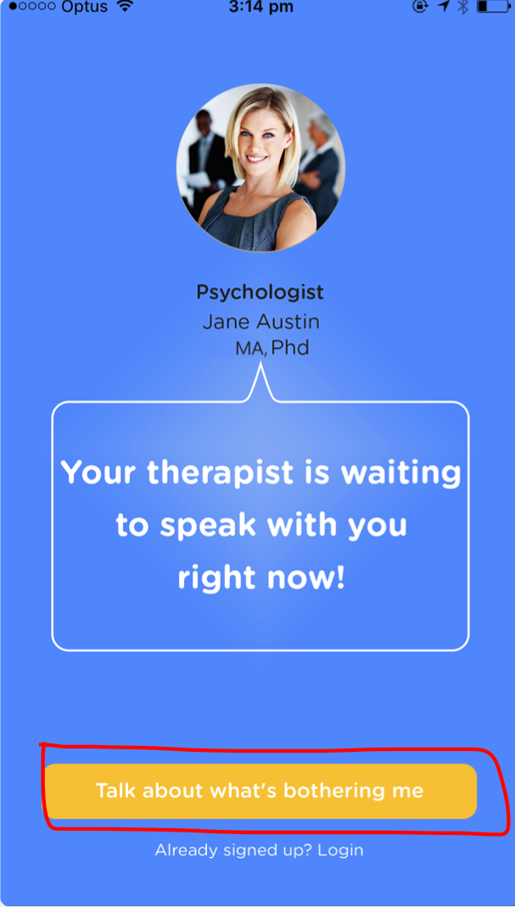
- Click ‘register’
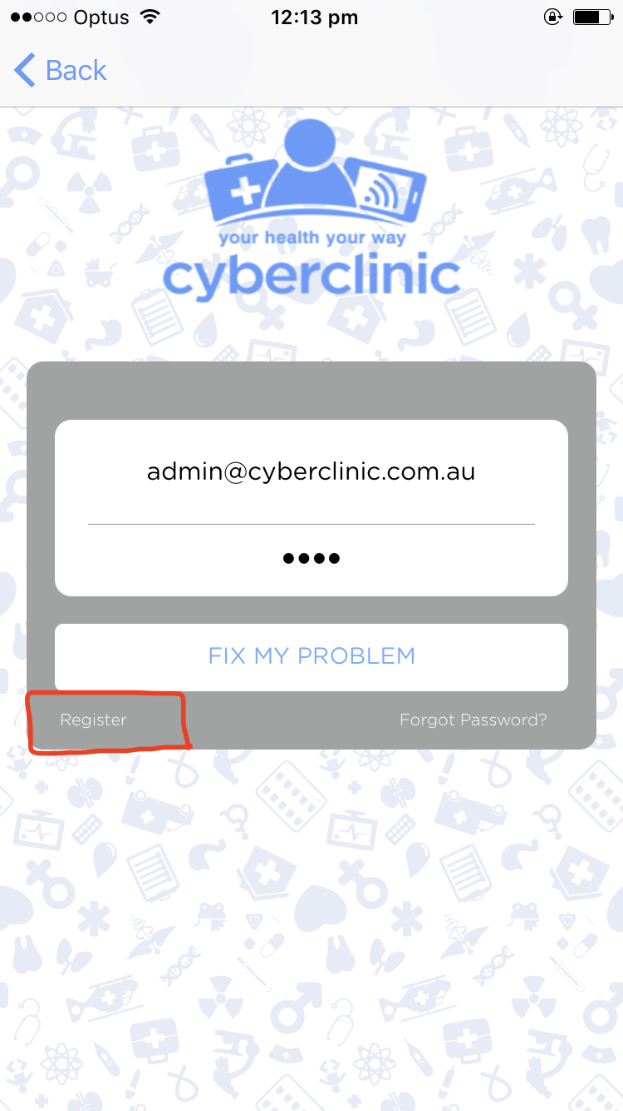

- Enter in your name, email and password twice and click proceed.
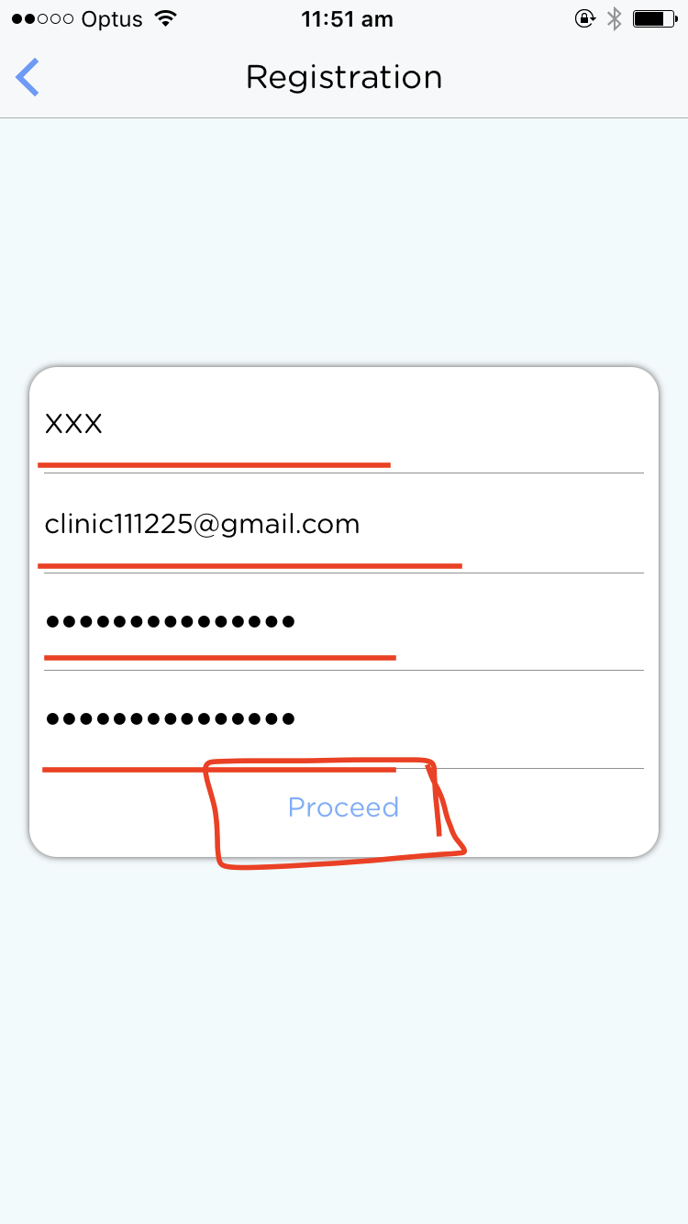
- Check your email for the verification code.
- Enter the code and click ‘Verify’.
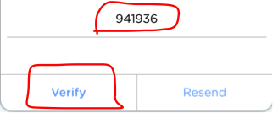
- Read the Terms and Conditions, tick if you agree and click ‘proceed’

Once registered you will need to do the following to BOOK AN APPOINTMENT:

- Click ‘Contract’
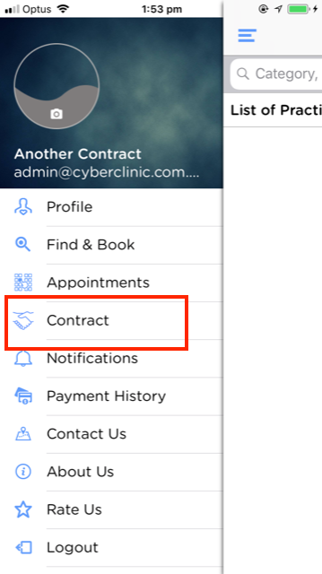
- Click ‘add contract’
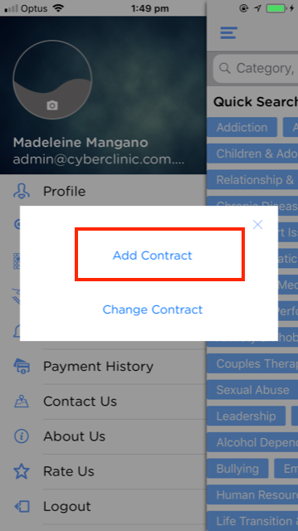
- Enter in your email address, and your contract key (a code you would have gotten from the EMPHN team or your psychologist can tell you it over the phone).
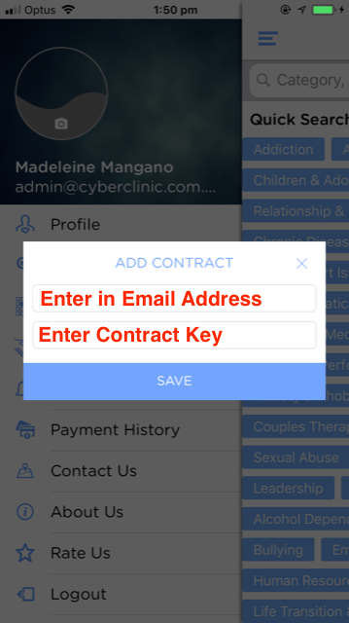
- Select the practitioner which shows up on the screen
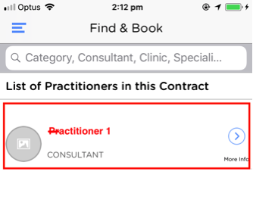

- Click ‘book’
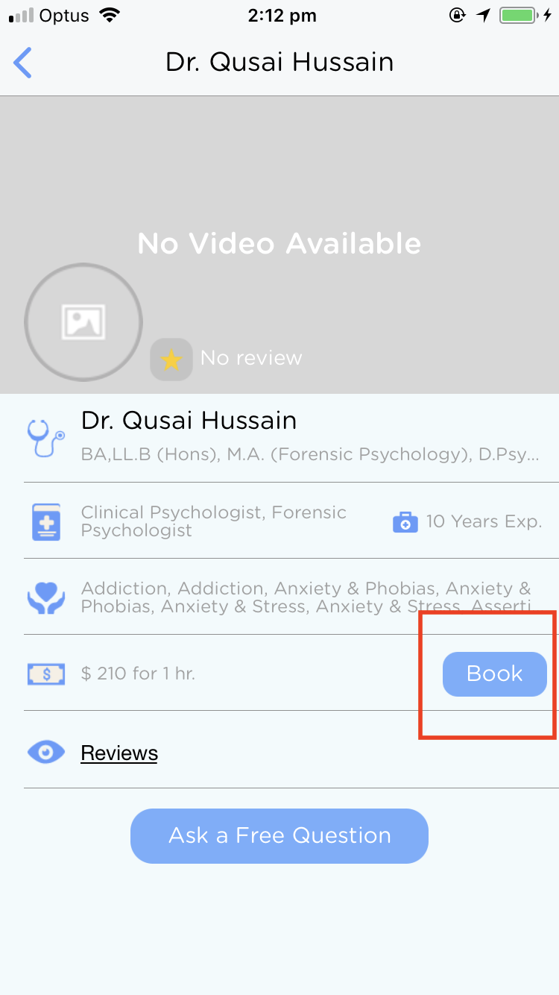

- Select appointment day/ time
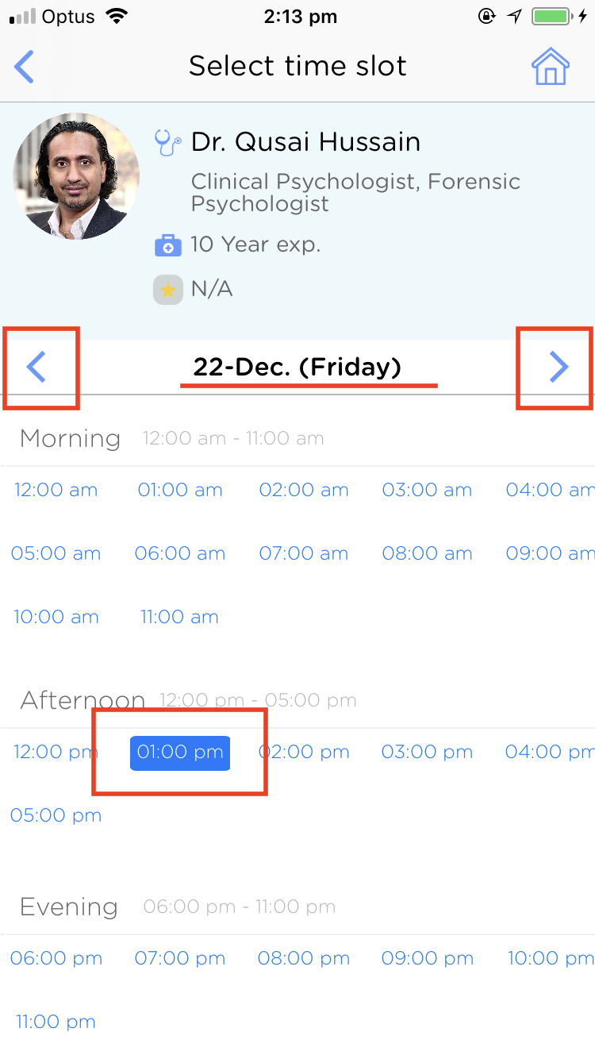

- Read the consent form, tick if you agree, click ‘proceed’.
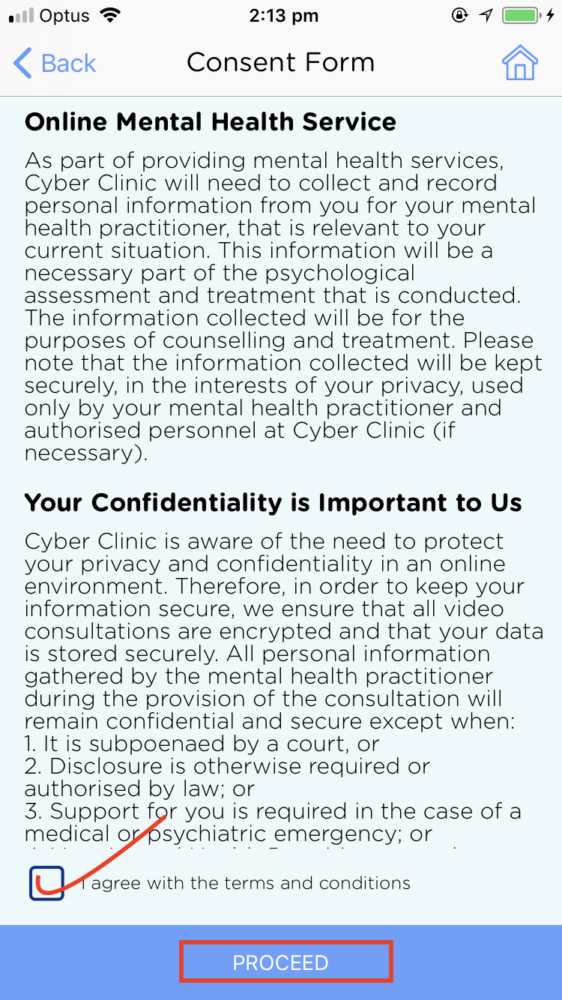
- Fill out the basic info under intake form and click ‘continue’
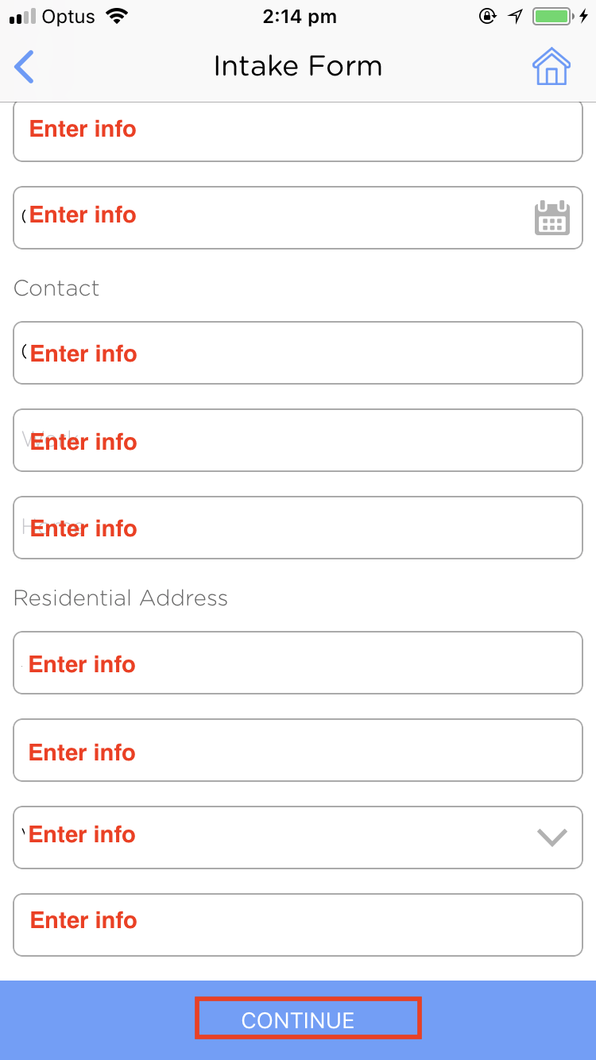

- Summarise your issue E.g. Anxiety, Depression.
- Enter in your Medicare Card details & referral details. Your psychologist can help you with any questions you have about this.
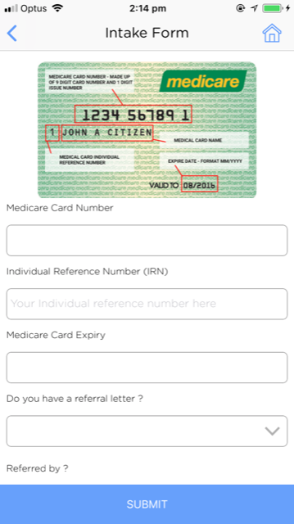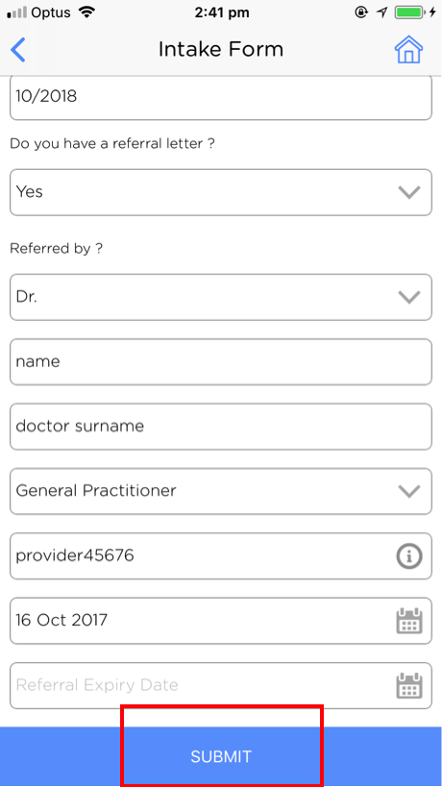

- Click ‘proceed to payment’ even though they are not paying
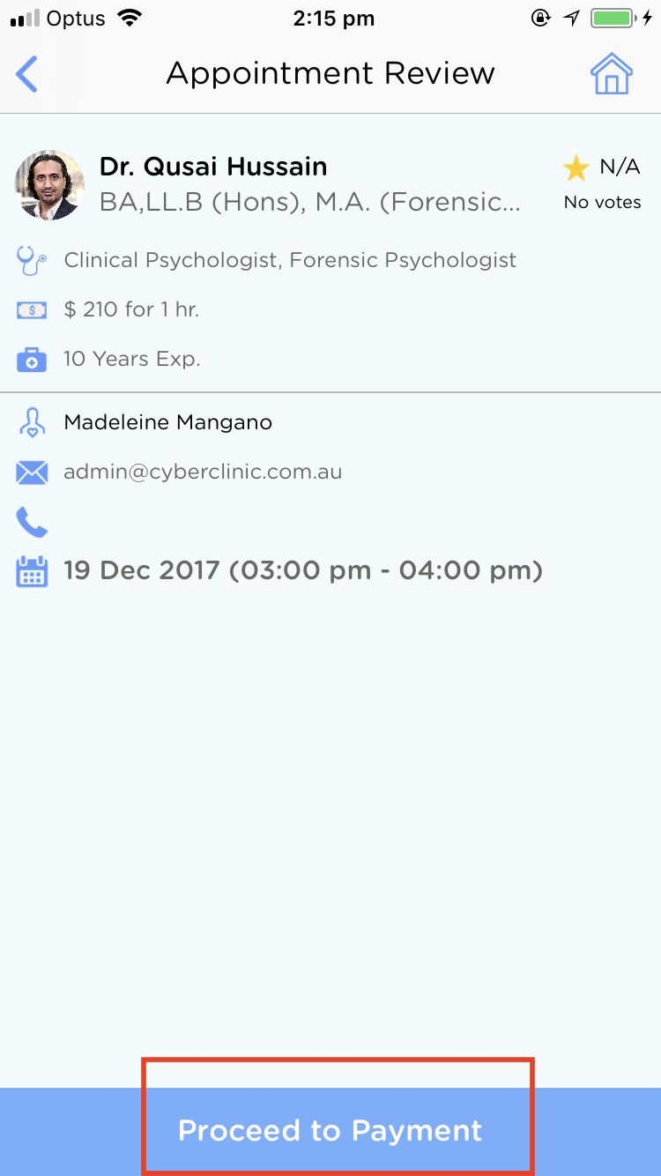

- A warning will come up “your have 24 hours notice to cancel your appointment otherwise your consultation will be forfeited’ – make sure you understand this and click ‘okay’.
- Click ‘ok’
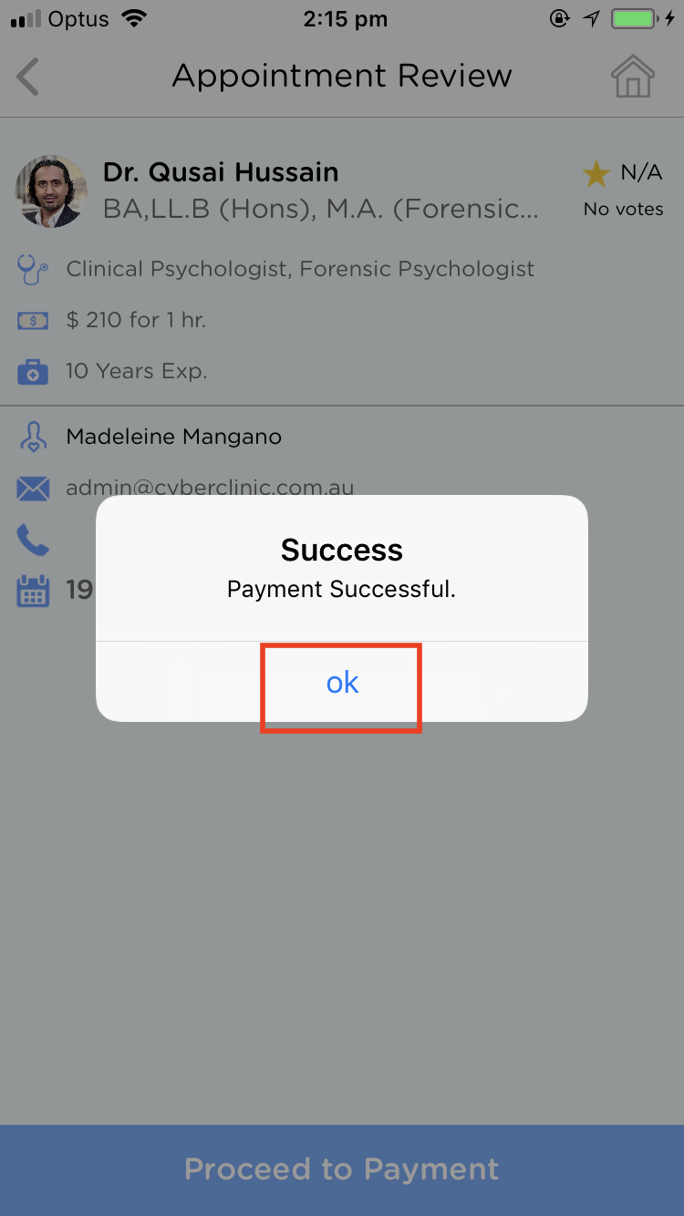
- The psychologist will have to check that you have booked the appointment successfully.

