PIP QI Activity – Preventative care for patients at high risk of hospitalisation.

Quality Improvement Activity for practices using POLAR data tool.

The following quality improvement activity and sample Plan Do Study Act (PDSA) may be used to assist your practice to pro-actively manage patients who are at high risk of hospitalisation. POLAR will provide you will a list of patients that are at high/urgent risk. The practice will also be able to see MBS eligibility for the following items:
- Health Assessments
- GPMP/TCA
- GPMP/TCA Reviews
- HMR
- Nurse Chronic Disease Item
- GP Mental Health Treatment Plan and Reviews
This QI activity will also assist practices to meet PIP QI requirements. Review each idea and select what may be appropriate for your practice to consider undertaking and test using PDSA cycles.
PIP QI Activity Reference
Activity topic: Targeting patients for preventative care activities who are at high risk of hospitalisation
Pro-actively contacting patients who are at risk of hospitalisation using the POLAR Hospitalisation Report (High Risk Patients)
Improvement Activity Start Date |  | Improvement Activity Completion Date | PIP QI Quarter Record
 |  |  | Select Quarter | PIP Quarter | PIP Quarterly Period
 |  |  |  | Q1 | November to January
 |  |  |  | Q2 | February to April
 |  |  |  | Q3 | May to July
 |  |  |  | Q4 | August to October
Identify the lead team at your practice who will be responsible to drive this quality improvement work
Name | Role/Responsibility

Goal: What are you trying to accomplish?
Tip: Create a SMART goal (Simple, Measurable, Achievable, Realistic and Timely). What do you want to achieve and by what date?
Lower the number of patients who are in the Urgent Risk list of the Hospitalisation Risk Report in POLAR

Measure: What data will you use to track your improvement journey?
Tip: Use this spreadsheet to capture your data to track your improvement journey. It is important to capture your baseline data before you start any improvement activity.
Data report/source used: POLAR
Measure/Data | Practice  Target | Date | Baseline  Data | Month/PIP Quarter
 |  |  |  | June 2020 | July 2020
Number of RACGP active patients who are in the Urgent Risk Catergory of the Hospitalisation Risk Report in POLAR (instructions at the end of this report)
Ideas: What changes will you make that will lead to an improvement (small steps)?
Tip: Capture a list of practical steps to undertake and test using PDSA cycles. Refer to Appendix A for a PDSA log and Appendix B for PDSA template to record your activities.

Ideas: How you plan to achieve your goal
- Assign data quality roles and responsibilities  - Allocate a person to be responsible for implementing the quality activities.  - Provide protected time for person to complete the targeted activities. | Date completed:
 | PDSA Completed (Yes/No):
 | Notes:
- Decide what you are going to do with the list of patients who are most at risk.  - Export the list to excel and sort by Most Seen Clinician and what MBS items are missing for these patients.  - Provide each GP with a list to review before contacting/recalling patients. | Date completed:
 | PDSA Completed (Yes/No):
 | Notes:
- When the lists have been reviewed recall patients for preventative health activities if appropriate. Remember to stagger appointments so GPs are not overwhelmed. Some of these items can be done via telehealth if they meet the criterion.  - Provide protected time to this allocated person to review the report on a regular basis.  - Ensure missing data is updated on the patient file (create notes)  - Ensure staff are provided with regular updates on how this piece of work is progressing.  - Check patient numbers in the report to ensure the number of patients is declining even if it is only slightly. | Date completed:
 | PDSA Completed (Yes/No):
 | Notes:

Appendix A: PDSA Log
PDSA Number | Pro-actively contacting patients who are at risk of hospitalisation using the POLAR Hospitalisation Report (High Risk Patients) |  |  |  | Do  Was the activity completed?  Any problems? | Study  Record, analyse and reflect on results. Did the results match your predictions? | Act  Decide to adopt, adapt or abandon
 | What | Who | When(date)  and where | Prediction
1 |  |  |  |  | Yes  No, if not why? |  | Adapt  Adopt  Abandon
2 |  |  |  |  | Yes  No, if not why? |  | Adapt  Adopt  Abandon
3 |  |  |  |  | Yes  No, if not why? |  | Adapt  Adopt  Abandon
4 |  |  |  |  | Yes  No, if not why? |  | Adapt  Adopt  Abandon
5 |  |  |  |  | Yes  No, if not why? |  | Adapt  Adopt  Abandon

Appendix B: PDSA Template
Idea |  |  |  |  | Date
Decrease the number of patients who are in the high risk Hospitalisation Risk report in POLAR.

PDSA Number:

Plan
Briefly, describe exactly what you will do?
Get a list of patients that are at high risk of hospitalisation from POLAR. Providing preventative health activities such as health assessments, care plans and other MBS items.

List the tasks necessary to complete this test (what) |  | Person responsible  (who) |  | When | Where
Meet with staff to discuss activity

Run POLAR searches for baseline data

Recall patients for care.
Run POLAR search monthly for comparison

What do you predict will happen?
- The number of patients on the High Risk of hospitalisation will decrease slightly.
- There will be less patients on the list that are missing MBS items
- There will be less patients on the list that are missing demographic/clinical information.
- Practice income will increase.

Do: Was the cycle carried out as planned? Yes No, if not why?
Study: Record, analyse and reflect on the results. Did the results match your predictions?
Act: Decide to adopt, adapt or abandon.
Select |  |  | Describe
Adopt | Select changes to implement on a larger scale and develop an implementation plan and plan for sustainability.
Adapt | Improve the change and continue testing plan.  What will be next PDSA cycle?
Abandon | Discard this change idea and try a different one.
Reflection report
As you complete quality improvement activities, it is important to take a moment to reflect on what your team has undertaken. A reflection report allows you to assess the successful changes you have made, the lessons learnt, and areas for further improvement. Completing this report will also provide an opportunity to consider activities you plan to undertake as a team to imbed continuous quality improvement within your general practice.
On reflection of the past QI activity period, what changes have you implemented and what have you learned as a result?
Provide an example of one innovative change/idea that did work well.

Provide an example of any roadblocks or ideas that did not work well.

What do you plan to work on next? Consider new ideas you will consider implementing to continue your improvement journey?
Collecting POLAR data:
Report | 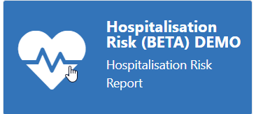
When you open the Report click in the RACGP Active to select patients that have been 3 or more times in 2 years. | 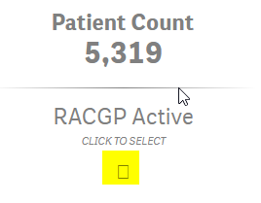
On the left hand side select the Box with Urgent Risk | 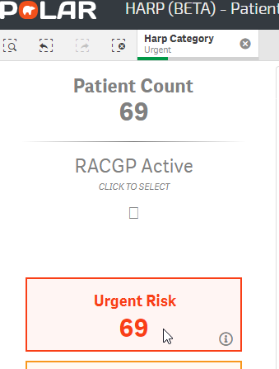
This is the number of patients who are the highest risk for hospitalisation | This is your baseline number for your PDSA
Use the POLAR walkthrough

Keep patients at high risk of hospitalisation at home through comprehensive preventative care. Using the Hospitalisation Risk Report In POLAR

Report | Hospitalisation Risk
When you open the Report in POLAR Click in the RACGP Active to select patients that have been 3 or more times in 2 years.
On the left hand side select the Box with Urgent Risk
Select the Patient Cohort tab along the top.  You now have a list of patients who are at high risk for being hospitalised. You will also be able to see if any demographic information is missing from the patient file. | 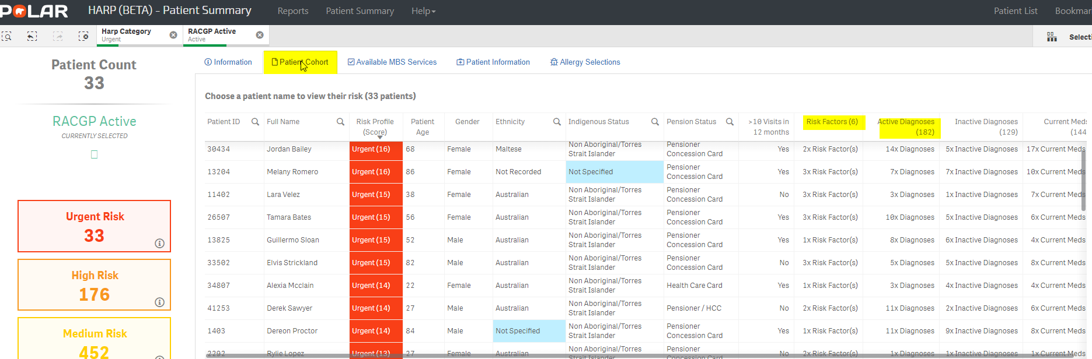
Select the Available MBS services tab. | 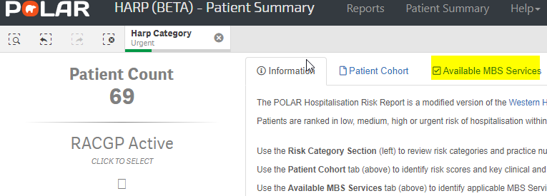
In the Available MBS Services tab, you now have a table with the high-risk patients and a list of MBS services if any that are available to the patient. Along with information regarding if they have had their SHS uploaded to the MYHR.  The color-coding will assist you with identifying which patients are missing their items of care that maybe due or have not been claimed at all. | 